Tables Presentation

Welcome
Introduction
When I first began…

Experience with tables:
0: I do not know anything about tables
1: I do it occasionally, but need to refer to my notes
2: I could teach this workshop

Agenda:
Creation of 2 different tables in Word
Best Practices for Microsoft
Convert Word Doc to PDF
And work on remediation
Questions

Why use tables?

Header row

Creation of tables

Simple Data Table

Marra’s Weekday Pizzeria
Monday | Tuesday | Wednesday | Thursday | Friday
Cheese | Cheese | Olives | Mushrooms | Pineapple
Pepperoni | Sausage | Sausage | Bacon | Ham and Pineapple

- Picture
- Tab for order
- Headers 1st row. Not first column.

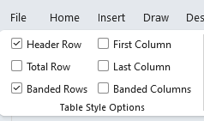

Complex tables
Cannot be made accessible in Word.
Monday | Tuesday | Wednesday | Thursday | Friday
Cheese |  | Olives | Mushrooms | Pineapple
Pepperoni | Sausage |  | Bacon | Ham and Pineapple

Monthly Movie Club
 | Student |  | Adult
 | Monthly Price | Annual Price | Monthly Price | Annual Price
One movie per month | $10 | $100 | $20 | $200
Discount for Auto Debit | Yes
One family pass per month (4 passes) | $20 | $200 | $50 | $500

Break up in separate tables as a solution for Word

Best Practices for Microsoft:

Merged Cells
Monday | Tuesday | Wednesday | Thursday | Friday
Cheese |  | Olives | Mushrooms | Pineapple
Pepperoni | Sausage |  | Bacon | Ham and Pineapple

Blank Cells
Monday | Tuesday | Wednesday | Thursday | Friday
Cheese |  | Olives | Mushrooms | Pineapple
Pepperoni | Sausage |  |  | Ham and Pineapple

Caption
Marra’s Weekday Pizzeria
Monday | Tuesday | Wednesday | Thursday | Friday
Cheese | Cheese | Olives | Mushrooms | Pineapple
Pepperoni | Sausage | Sausage | Bacon | Ham and Pineapple
1. Right click on table, then Insert Caption
Color Usage contrast/designation webaim.org
Monday | Tuesday | Wednesday | Thursday | Friday
Cheese | Cheese | Olives | Mushrooms | Pineapple
Pepperoni | Sausage | Sausage | Bacon | Ham and Pineapple
items are gluten free

Tables properties
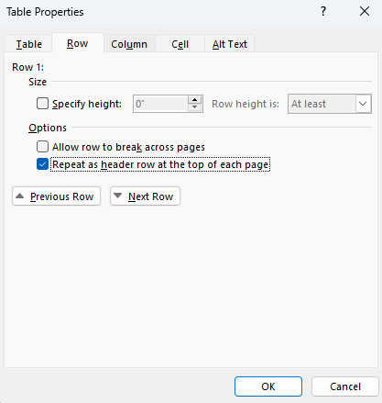

Single Table Per Sheet -Sheet 1 (Excel)
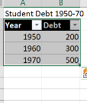

Meaningful tab names (Excel)
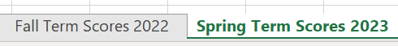

Unicode symbols
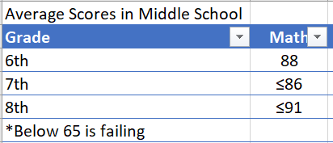

Accessibility Checker, simple tables
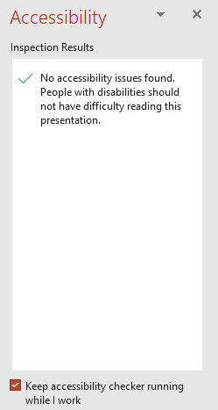

Convert Word Doc to PDF
Do not use Print to PDF.

Work on Remediation
- Review Tags panel for table.
- Use Reading Order to set the scope.
- Autogenerate cell IDs.
- Associate header IDS for data.
- Run Accessibility Checker.

Remediation Tools

Questions
Marra Piazza Brass
AMA Consulting
mpiazzabrass@ama-consult.com

Resources
Section 508 Creating Accessible Documents
Section 508 Training Videos
WebAIM
Section 508 Color Contrast

